SIMATS ENGINEERING
Department of Computer Science and Engineering
ASSESSMENT TOOL 1 – CONSTRAINT-BASED PROBLEM SOLVING
Course Code: | CSA1220 | Course Title: | Computer Architecture
CO Assessed: | CO5 – Precision (BL4) | Assessment: | Constraint Based Problem Solving
Weightage: | 40% | Total Marks: | 100
CO5 Statement: | Construct I/O communication mechanisms by comparing memory-mapped and I/O-mapped techniques, interrupt handling (vectored, hardware, software), DMA controllers, and advanced bus interfaces including PCIe, USB, NVMe, and Thunderbolt.
Student Name: | P.Rishitha | Reg. No.: | 192472396
Section / Batch: | 2024 | Date: | 26/08/2026

Instructions to Students
• Identify the relevant concepts of I/O interfaces, interrupts, DMA, bus arbitration, and high-speed communication protocols. • Analyze the I/O requirements considering CPU utilization, latency, throughput, bandwidth, and device priorities. • Apply suitable I/O techniques such as DMA, vectored interrupts, memory-mapped I/O, nested interrupts, and bus arbitration. • Compute performance measures such as data transfer rate, interrupt latency, CPU utilization, throughput, and transfer time. • Interpret the results by evaluating CPU efficiency, communication performance, interrupt response, and suitability of the proposed I/O architecture.

QUESTIONS
1. Design an I/O subsystem for a real-time robotic arm controller with the following constraints: • Position sensors generate data every 500 µs.
• Control commands must be processed within 5 µs.
• Use priority-based interrupt handling for critical sensors.
• Non-critical diagnostic data must be transferred using DMA.
2. Construct a communication architecture for an autonomous vehicle with the following constraints:
• Multiple cameras generate a combined data rate of 2 GB/s.
• Safety-critical sensors require deterministic response time.
• Use PCIe for high-bandwidth devices.
• Ensure that low-priority devices do not affect safety-critical communication. 3. Design an I/O mechanism for an industrial monitoring system with the following constraints: • 100 sensors continuously generate measurement data.
• The system must support real-time fault detection.
• Use interrupt coalescing to reduce processor overhead.
• Critical fault signals must receive immediate interrupt service.
4. Construct a high-speed network interface subsystem with the following constraints: • Network traffic can reach 10 Gb/s.
• The CPU must be protected from excessive packet-processing overhead.
• Use DMA-based packet transfer between the network interface and memory. • Generate interrupts only after processing a configurable batch of packets.
5. Design an I/O architecture for a smart healthcare monitoring system with the following constraints:
• Patient-monitoring devices generate data at different sampling rates.
• Emergency signals must be handled with highest priority.
• Use nested interrupt handling for urgent events.
• Store continuous monitoring data using DMA transfers without interrupting critical processing.
Code of Conduct
I __________________________ (Name / Reg No) certify that this submission is my original work and that I have adhered to the guidelines specified for this assessment. I understand that any violation of academic integrity rules will result in disciplinary action.
Signature of the Student: _________________________
RUBRICS FOR CALCULATION
Criteria | Weightage(%) | Level 4 – Exemplary (5 Marks) | Level 3 –  Proficient (4  Marks) | Level 2 –  Developing  (2–3 Marks) | Level 1 – Beginning (0–1 Mark)
Problem  Understanding | 25% | Clearly defines the problem and  identifies all relevant constraints  accurately | Identifies most constraints with minor gaps | Partial  understanding;  misses key  constraints | Fails to identify  constraints  correctly
Constraint  Analysis | 25% | Analyzes constraints effectively and  prioritizes them  logically | Provides  reasonable  analysis with  some  prioritization | Limited analysis; weak  prioritization | No meaningful  analysis or  prioritization
Solution  Development | 25% | Develops optimal and feasible  solutions satisfying all constraints | Develops  workable  solutions with  minor limitations | Solutions partially satisfy constraints | Solutions do not  meet constraints
Application of Concepts | 15% | Effectively applies appropriate concepts, methods, or tools | Applies concepts with minor errors | Limited  application;  requires guidance | Unable to apply  relevant concepts
Justification | 10% | Provides strong  justification for  decisions with  logical reasoning | Provides  justification with some clarity | Weak or unclear justification | No justification  provided

Marks Evaluation:
Q.  No | Problem  Understanding  (25) |  | Constraint  Analysis (25) |  | Solution  Development (25) | Application of Concepts (15) | Justification  (10) | Total  (out of 100)
1 | / 4 |  | / 4 |  | / 4 | / 4 | / 4
2 | / 4 |  | / 4 |  | / 4 | / 4 | / 4
3 | / 4 |  | / 4 |  | / 4 | / 4 | / 4
4 | / 4 |  | / 4 |  | / 4 | / 4 | / 4
5 | / 4 |  | / 4 |  | / 4 | / 4 | / 4
 | / 25 |  | /25 |  | / 25 | / 15 | / 10 | / 100

Course Coordinator Faculty Incharge

1. Design of an I/O Subsystem for a Real-Time Robotic Arm Controller

Aim
To design an efficient I/O subsystem for a real-time robotic arm controller where position sensors generate data every 500 µs, control commands are processed within 5 µs, critical sensors use priority-based interrupt handling, and non-critical diagnostic information is transferred using DMA.

System Requirements
The robotic arm controller must:
- Receive position sensor data every 500 microseconds.
- Process critical control commands within 5 microseconds.
- Give high priority to critical position sensors.
- Transfer non-critical diagnostic information without increasing CPU workload.
- Maintain reliable and deterministic real-time operation.
- Proposed I/O Architecture :

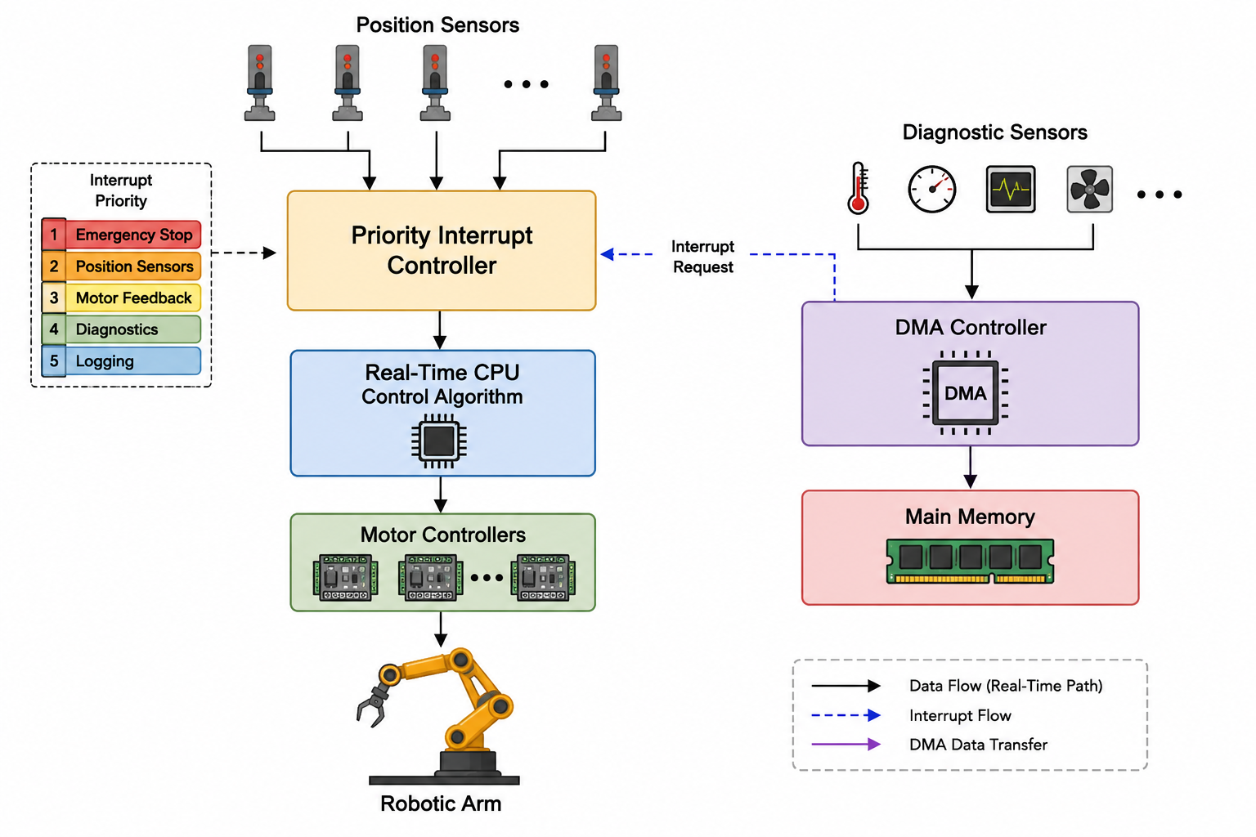

Working Principle
The robotic arm contains position sensors that continuously monitor the location and movement of the robotic joints. These sensors generate new position information every 500 µs.
Whenever a critical position sensor generates data, an interrupt is sent to the priority interrupt controller. The interrupt controller checks the priority of the interrupt. Critical sensor interrupts are assigned the highest priority.
The CPU immediately services the critical interrupt and obtains the sensor information. The real-time control algorithm processes the position data and calculates the required motor movement. The control command is then sent to the motor controller.
The complete control operation must be performed within 5 µs to achieve accurate and safe robotic movement.
Non-critical diagnostic information, such as temperature, motor usage statistics, and system logs, does not require immediate CPU attention. Therefore, this information is transferred directly to main memory using the DMA controller.
DMA allows data transfer between the diagnostic device and memory without continuous CPU involvement.

Priority-Based Interrupt Handling
The interrupt priority can be arranged as follows:

Priority | Device/Event | Action
Highest | Emergency stop | Immediate processing
High | Position sensor | Real-time control
Medium | Motor feedback | Control adjustment
Low | Diagnostic data | DMA transfer
Lowest | System logging | Background processing

Timing Analysis
- Position sensor data generation: Every 500 µs
- Maximum control command processing time: 5 µs
- Remaining time before the next sensor update: approximately 495 µs
Therefore, the system has enough time to complete the critical control operation before the next position data arrives.

Advantages
- Provides fast real-time response.
- Critical sensor data receives immediate attention.
- Priority interrupts improve system reliability.
- DMA reduces CPU workload.
- Diagnostic operations do not interfere with control operations.
- The architecture supports deterministic robotic arm movement.

Result
Thus, the proposed I/O subsystem successfully supports a real-time robotic arm by processing critical sensor data using priority-based interrupts and completing control operations within 5 µs, while DMA handles non-critical diagnostic data efficiently.

IMPLEMENTATION :
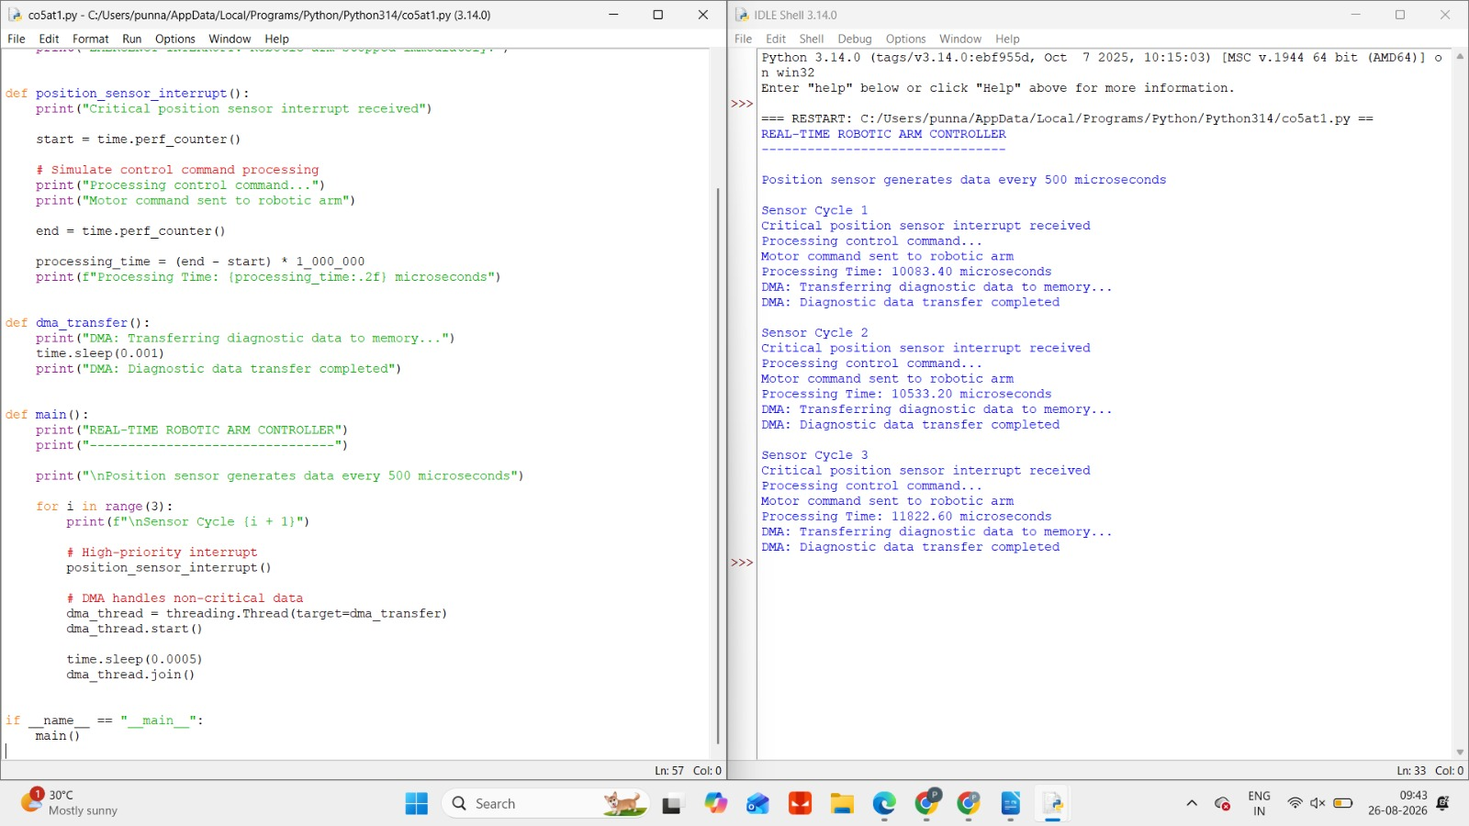

2. Communication Architecture for an Autonomous Vehicle

Aim
To construct a high-speed and reliable communication architecture for an autonomous vehicle where multiple cameras generate 2 GB/s of data, safety-critical sensors require deterministic response, PCIe is used for high-bandwidth devices, and low-priority devices must not affect safety-critical communication.

System Requirements
The autonomous vehicle must:
- Process camera data at a combined rate of 2 GB/s.
- Support deterministic communication for safety-critical sensors.
- Use PCIe for high-bandwidth communication.
- Prevent low-priority devices from delaying critical messages.
- Support reliable real-time decision-making

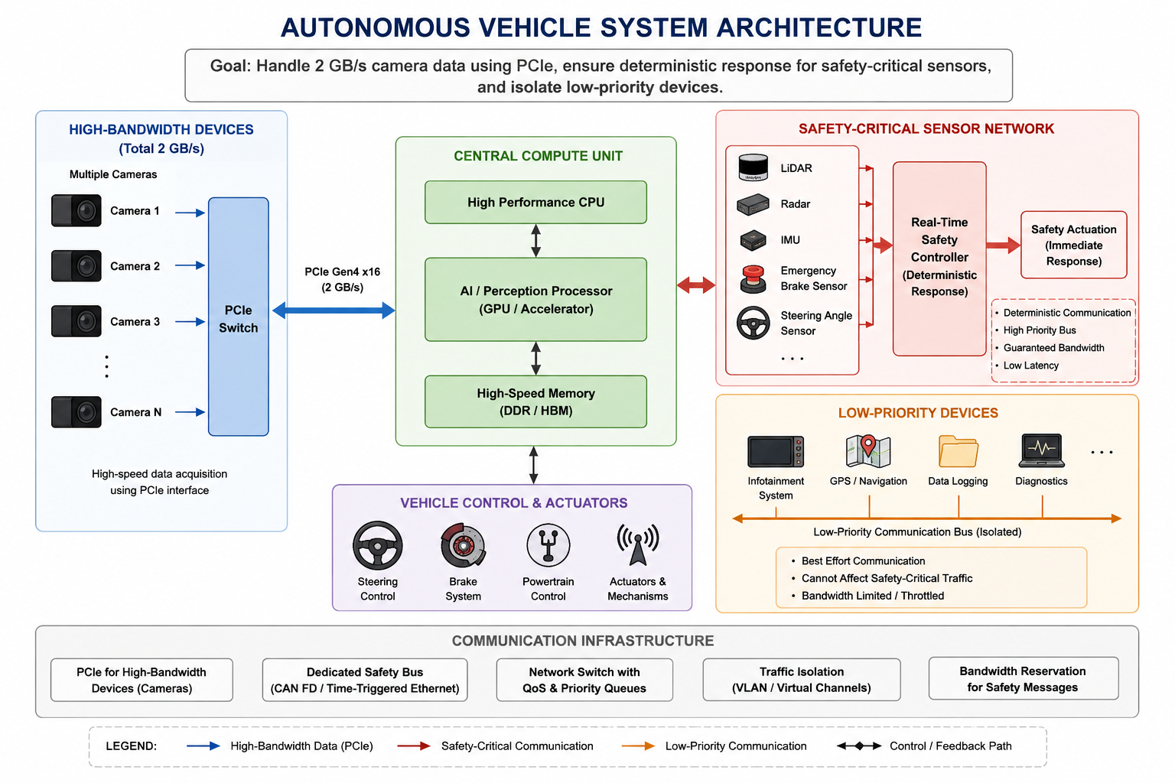

Working Principle
Autonomous vehicles use multiple cameras to detect roads, vehicles, pedestrians, traffic signals, and obstacles. These cameras generate a large amount of data at approximately 2 GB/s.
PCIe is used because it provides a high-speed communication interface between cameras, processors, memory, and AI accelerators.
Safety-critical sensors such as:
- LiDAR
- Radar
- Collision sensors
- Brake sensors
- Steering sensors
require deterministic communication. This means their messages must reach the vehicle controller within a predictable time.
Therefore, these sensors are assigned a dedicated high-priority communication path.
Low-priority devices such as:
- Entertainment systems
- Logging devices
- Non-critical GPS services
- Passenger systems
are placed on separate communication channels or assigned lower priority.

Communication Priority

Priority | Device Type | Communication Requirement
Highest | Emergency braking | Immediate
High | Radar and collision sensors | Deterministic
High | LiDAR | Real-time
Medium | Cameras | High bandwidth
Low | GPS | Normal
Lowest | Entertainment system | Non-critical

PCIe Communication
PCIe is suitable for high-bandwidth devices because it provides:
- High data transfer speed.
- Low latency.
- Scalable bandwidth.
- Efficient communication with GPUs and AI processors.
The camera data is transferred through PCIe to the central processing system.

Isolation of Low-Priority Devices
To ensure that low-priority communication does not affect safety-critical traffic, the architecture uses:
- Separate communication channels.
- Priority queues.
- Bandwidth reservation.
- Traffic isolation.
- Real-time scheduling.
For example, even if a large amount of entertainment data is being transferred, emergency braking communication is processed first.

Advantages
- Supports 2 GB/s camera data.
- Provides deterministic response for critical sensors.
- Uses PCIe for high-speed communication.
- Prevents low-priority traffic from affecting safety.
- Supports reliable autonomous vehicle operation.

Result
Thus, the proposed communication architecture successfully combines high-bandwidth PCIe communication for camera systems with deterministic priority communication for safety-critical sensors.
IMPLEMENTATION :
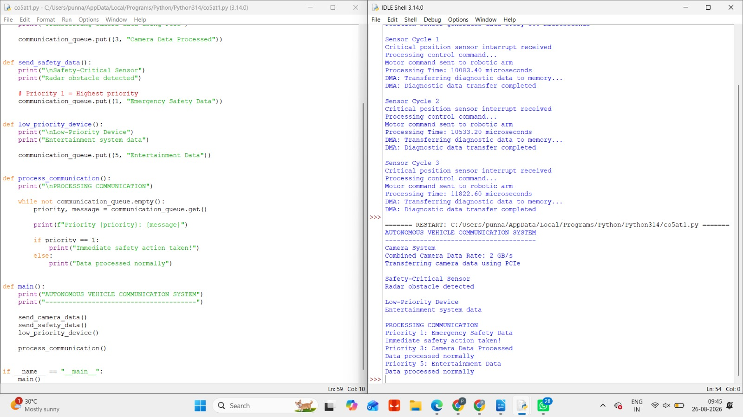

3. Design of an I/O Mechanism for an Industrial Monitoring System

Aim
To design an I/O mechanism for an industrial monitoring system containing 100 continuously operating sensors, supporting real-time fault detection, using interrupt coalescing to reduce CPU overhead, and providing immediate service for critical fault signals.

System Requirements
The system must:
- Monitor 100 sensors continuously.
- Detect industrial faults in real time.
- Reduce excessive processor interrupts.
- Use interrupt coalescing for normal sensor data.
- Immediately process critical fault signals.

Working Principle
The industrial monitoring system receives continuous measurements from 100 sensors. If every sensor generates an interrupt for every measurement, the CPU may spend most of its time servicing interrupts.
To solve this problem, the system uses interrupt coalescing.
In interrupt coalescing, the system collects multiple sensor events before generating a single interrupt.

Critical Fault Handling
Critical fault signals must not wait for interrupt coalescing.
Examples include:
- Fire detection.
- Gas leakage.
- Machine overheating.
- Dangerous pressure levels.
- Electrical failure.
- Emergency stop signals.
These signals immediately generate a high-priority interrupt.
The CPU immediately suspends less important processing and services the critical fault.
Interrupt Priority :

Priority | Event | Processing
Highest | Emergency shutdown | Immediate
High | Critical fault | Immediate
Medium | Abnormal sensor value | Fast processing
Low | Normal sensor data | Coalesced interrupt
Lowest | Logging | Background

Advantages
- Supports continuous monitoring of 100 sensors.
- Reduces CPU overhead.
- Provides real-time fault detection.
- Critical faults receive immediate attention.
- Improves industrial safety.
- Makes efficient use of processor resources.

Result
Thus, the industrial monitoring system uses interrupt coalescing to efficiently process normal sensor data while providing immediate high-priority interrupt service for critical fault conditions.
IMPLEMENTATION :
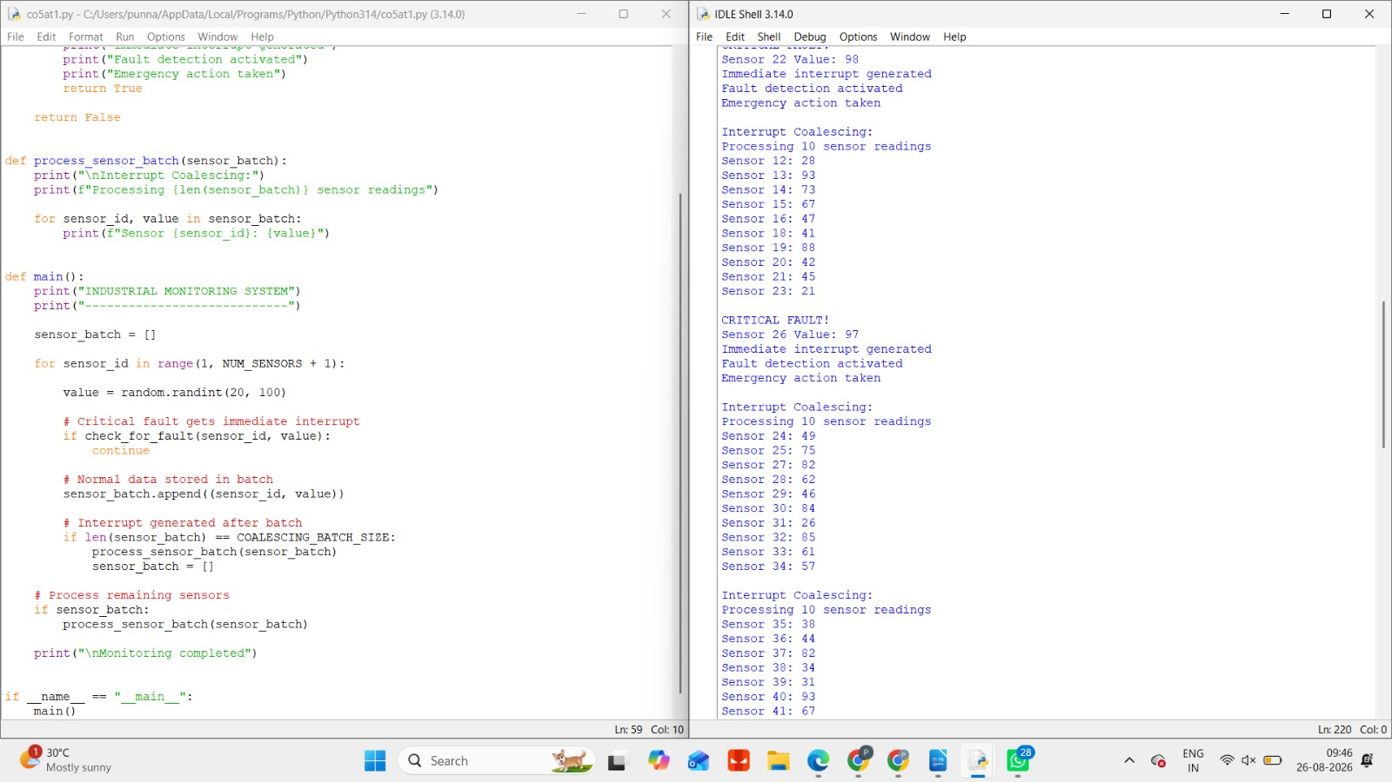

4. High-Speed Network Interface Subsystem

Aim
To design a high-speed network interface subsystem capable of handling traffic up to 10 Gb/s, protecting the CPU from excessive packet-processing overhead, using DMA-based packet transfer, and generating interrupts only after a configurable batch of packets is processed.

System Requirements
The network interface must:
- Support up to 10 Gb/s network traffic.
- Reduce CPU packet-processing overhead.
- Use DMA for packet transfer.
- Transfer packets directly to memory.
- Generate interrupts after a configurable packet batch.

DMA-Based Packet Transfer
Without DMA:
Network -> NIC -> CPU -> Memory
The CPU must handle every packet transfer.
With DMA:
Network -> NIC -> DMA -> Main Memory
|
v
CPU
The DMA controller transfers packet data directly from the NIC to main memory.
The CPU is only notified when packet processing is required.

Interrupt Batching
Generating an interrupt for every packet would create excessive CPU overhead.

Configurable Batch Size
A smaller batch provides:
- Lower latency.
- More frequent interrupts.
A larger batch provides:
- Lower CPU overhead.
- Higher processing efficiency.
Therefore, the system can adjust the batch size based on current network traffic.

Advantages
- Supports high-speed 10 Gb/s communication.
- DMA reduces CPU workload.
- Interrupt batching reduces interrupt overhead.
- Configurable batch size provides flexibility.
- Improves overall network performance.

Result
Thus, the high-speed network interface subsystem efficiently handles 10 Gb/s traffic by using DMA for packet transfer and interrupt batching to prevent excessive CPU overhead.
IMPLEMENTATION :
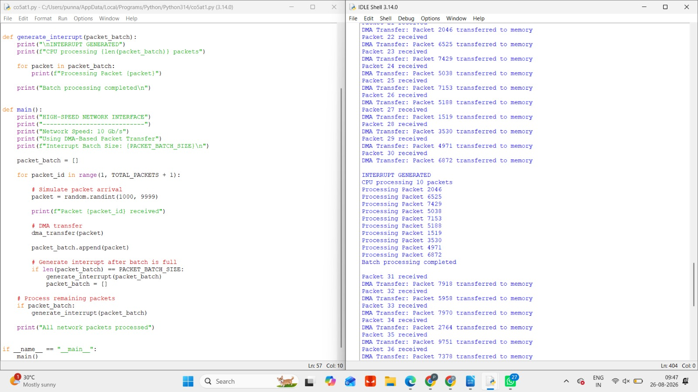

5. I/O Architecture for a Smart Healthcare Monitoring System

Aim
To design an I/O architecture for a smart healthcare monitoring system where devices generate data at different sampling rates, emergency signals receive the highest priority, nested interrupt handling is used for urgent events, and continuous monitoring data is stored using DMA.

System Requirements
The healthcare system must:
- Support multiple patient-monitoring devices.
- Handle different sampling rates.
- Detect emergency conditions immediately.
- Assign the highest priority to emergency signals.
- Use nested interrupts for urgent events.
- Use DMA for continuous data storage.

Different Sampling Rates
Different devices generate information at different speeds.
For example:

Device | Sampling Rate
ECG | Very high
Heart rate monitor | High
Oxygen monitor | Medium
Blood pressure monitor | Periodic
Temperature sensor | Low

The I/O architecture must manage all these devices efficiently.

Emergency Signal Handling
Emergency events include:
- Cardiac arrest.
- Extremely low oxygen level.
- Dangerous heart rate.
- Critical blood pressure.
- Sudden patient distress.
These signals are assigned the highest interrupt priority.
When an emergency signal occurs, the CPU immediately starts emergency processing.
IMPLEMENTATION :
